We need to install 3 services in windows manually.

1. Salt Auto Report Service

Copy all release files to a folder (say C:\Program Files\BlackDawson\ SALTserviceQueueMail) in the destination machine.

Open a command line window ‘**as Administrator’** and run the following command:

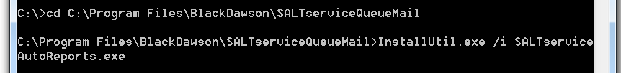

(should you ever wish to uninstall a service type (say) InstallUtil.exe **/u** SALTserviceAutoReports.exe)

At this time, go to services control panel, you will see a Service call “SALTserviceAutoReports” was created there. Right click and change the “Log On” property to your local administrator. (or a user with permission to WRITE to the relevant registry keys for SALT SERVICES)

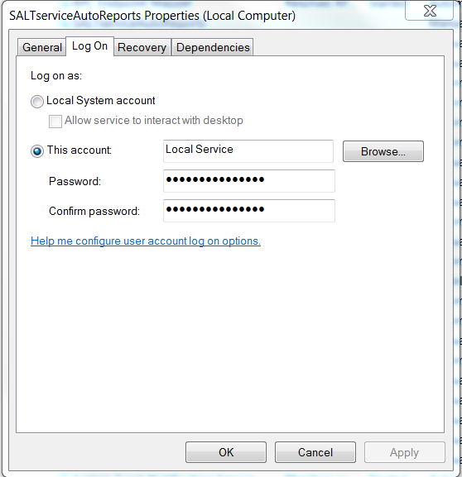

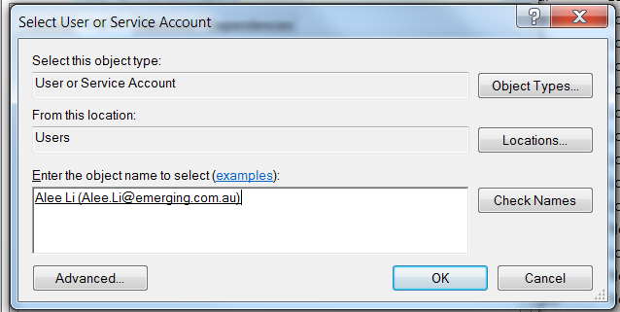

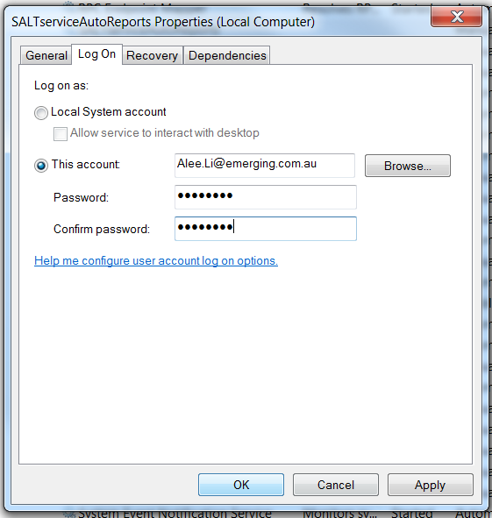

1. Salt Email Send Service
2. Copy all release files to a folder (say C:\Program Files\BlackDawson\ SALTserviceQueueMail) in the destination machine.

Open command line window ‘as Administrator’, and go to C:\Program Files\BlackDawson\SALTserviceSendMail, and type below command:



Then a window will pop out, and need to provide local admin password:

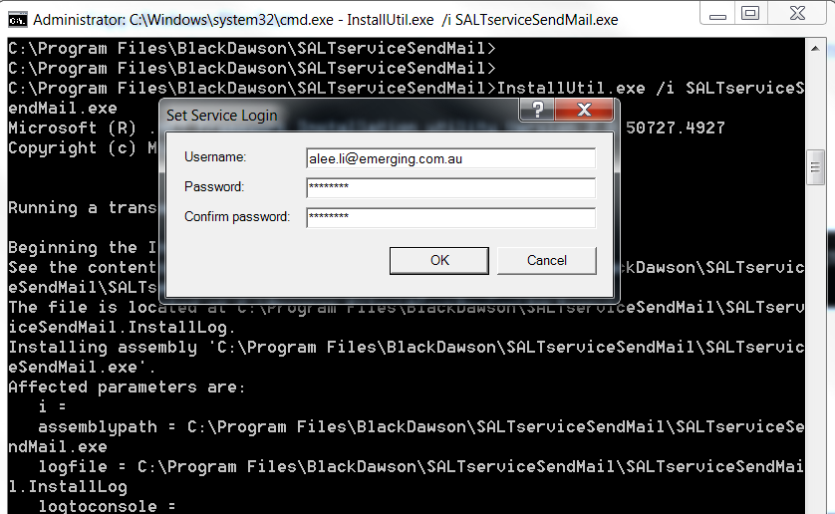

Then you will get “SALTserviceSendMail” installed in service control panel.

1. Salt Automade Email Service
2. Copy all release files to a folder (say C:\Program Files\BlackDawson\ SALTserviceQueueMail) in the destination machine.

Open command line window as an Administrator, and go to C:\Program Files\BlackDawson\ SALTautomatedEmails , and type below command:



You will get the same window, provide username and password as well. Then you will get “SALTServiceAutomatedEmails” service installed.

1. Modify register table of window



Modify the key value as below in the computer\hkey_current_user\soteware\blakedawson\salt:

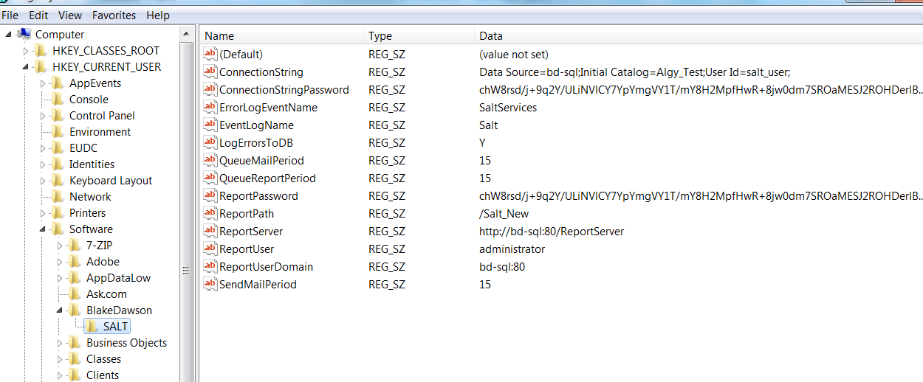

Another example is:

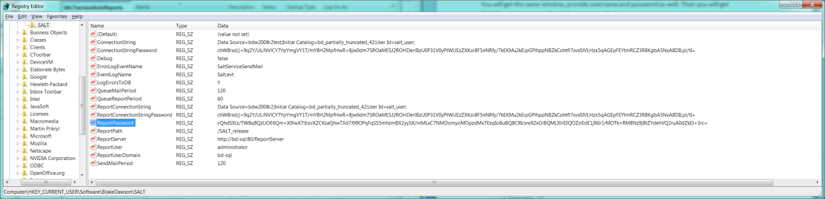

Then go to control panel to start the 3 services. Done.

N.B. IF THE DEBUG PARAMETER (in the Registry settings)IS SET TO ‘TRUE’ THE ENCRYPTED PASSWORD AND THE DECRYPTED PASSWORD WILL BE SAVED IN THE EVENTLOG!!!

If the registry settings are correct the Services will start and log any errors to tblErrorLog (you can view this from the SALT application – administration\view error log.

If the Registry settings (particularly the connection string or password) are not correct the services will be unable to connect to the database and therfore unable to write to tblErrorLog, in this case set debug = ‘true’ in the Registry and monitor the ‘Application log’ in ‘event viewer’ for errors:

